FLEXA Digital Pirani Vacuum Gauge FGE-2GH

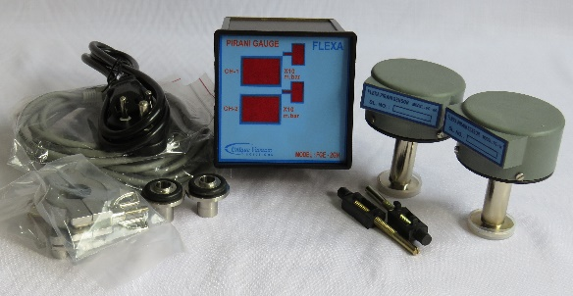
The UVS Model FLEXA series Vacuum Pirani Gauge Controller displays vacuum pressure as measured from a FG-04 sensor tube. The Model FGE-2GH unit covers the range from 0.001 m.Bar to 20 m.bar, and measures two channels.
Exponential order display from 2.0X10¹ to 1.0X10⁻³ mbar

The Advantage Of This Vacuum Gauge FLEXA Series Is The Sensor Tube Has The Built In Zero And Atm Adjustments, So That The Sensor Tube Can Be Used As A Transducer, And Each Sensor Is Factory Calibrated At Sensor Level.
With This 1:1 Replacement Of Sensor With The Display Unit Is Established, And There Is No Dependency On Vacuum Gauge Level Adjustment In Case Of Sensor Replacement.

TECHNICAL SPECIFICATIONS
Number of sensor channels | TWO
Display Range | 1000 mBar to 0.001mBar.
Measuring Range | 20 mBar to 0.001mBar.
Units of Display | m.Bar
Vacuum Gauge Head | FG-04 sensor tube
Temp. Range | +2 to +50 deg. Celsius
VAC. Display | 4-digit bright red LED, 14 mm high
VAC and ATM Adjust | adjusted by trim pot at the signal conditioner PCB of the sensor.
Process control set points | NIL
Process Control Relays | NIL
Nonvolatile Memory | NIL
Operating Voltage | universal power supply, input voltages from 90 ~ 264VAC 50/60 Hz
Mounting | ¼ DIN 92 x 92 mm (3.62” x 3.62")
Environmental Considerations | not for use with explosive or corrosive gases
Overall dimensions | 92mm X 92mm X 110mm Depth
Optional outputs on request | RS485, 0 -10V Dc analog output (OPTIONAL)
Sensor cable | Standard RJ45 male plugs both ends- 2 mtrs long. Optional additional lengths available on request.
Features at a Glance : ■ Measurement range 0.001 to 20 mbar ■ Two channel measurement ■ Space saving rugged design- 1/8 DIN console ■ Mounts in any orientation ■ brass body measuring cell with metal-sealed feed through ■ interchangeability of the sensor possible without disturbing the display unit.
Applications: ■ Controlling high vacuum systems ■ Fore vacuum pressure monitoring ■ Safety circuits in vacuum systems ■ General vacuum measurement & control in the fine and rough vacuum range.
Calibration:
Unique Vacuum Solutions offers a convenient recalibration service to help users of vacuum measurement pirani/ thermocouple/ full range gauges to maintain all of their vacuum gauges in Certified and peak condition, regardless of the original manufacturer. All makes of vacuum gauges can also be calibrated / repaired if required.
The calibration certificates are available only on request at additional cost. Pl contact before ordering.

UNIQUE VACUUM SOLUTIONS
#57, 8th cross, 1st B cross, Doddanna industrial area main road, vishwaneedam post, Near Peenya 2nd stage, Bangalore -560091
Ph: 080-28367059, 9886726920. +91-support@uniquevacuum.co.in, www.uniquevacuum.co.in

